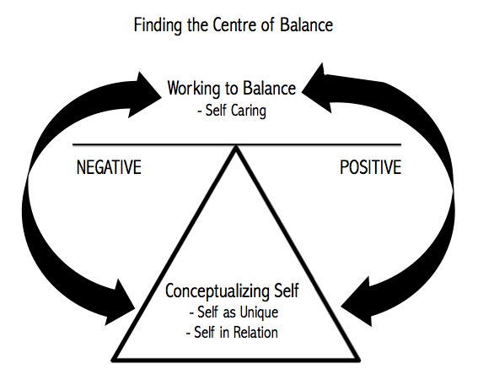
Figure 1. Finding the Centre of Balance – A Preliminary Model of Maintaining Positive Embodiment

