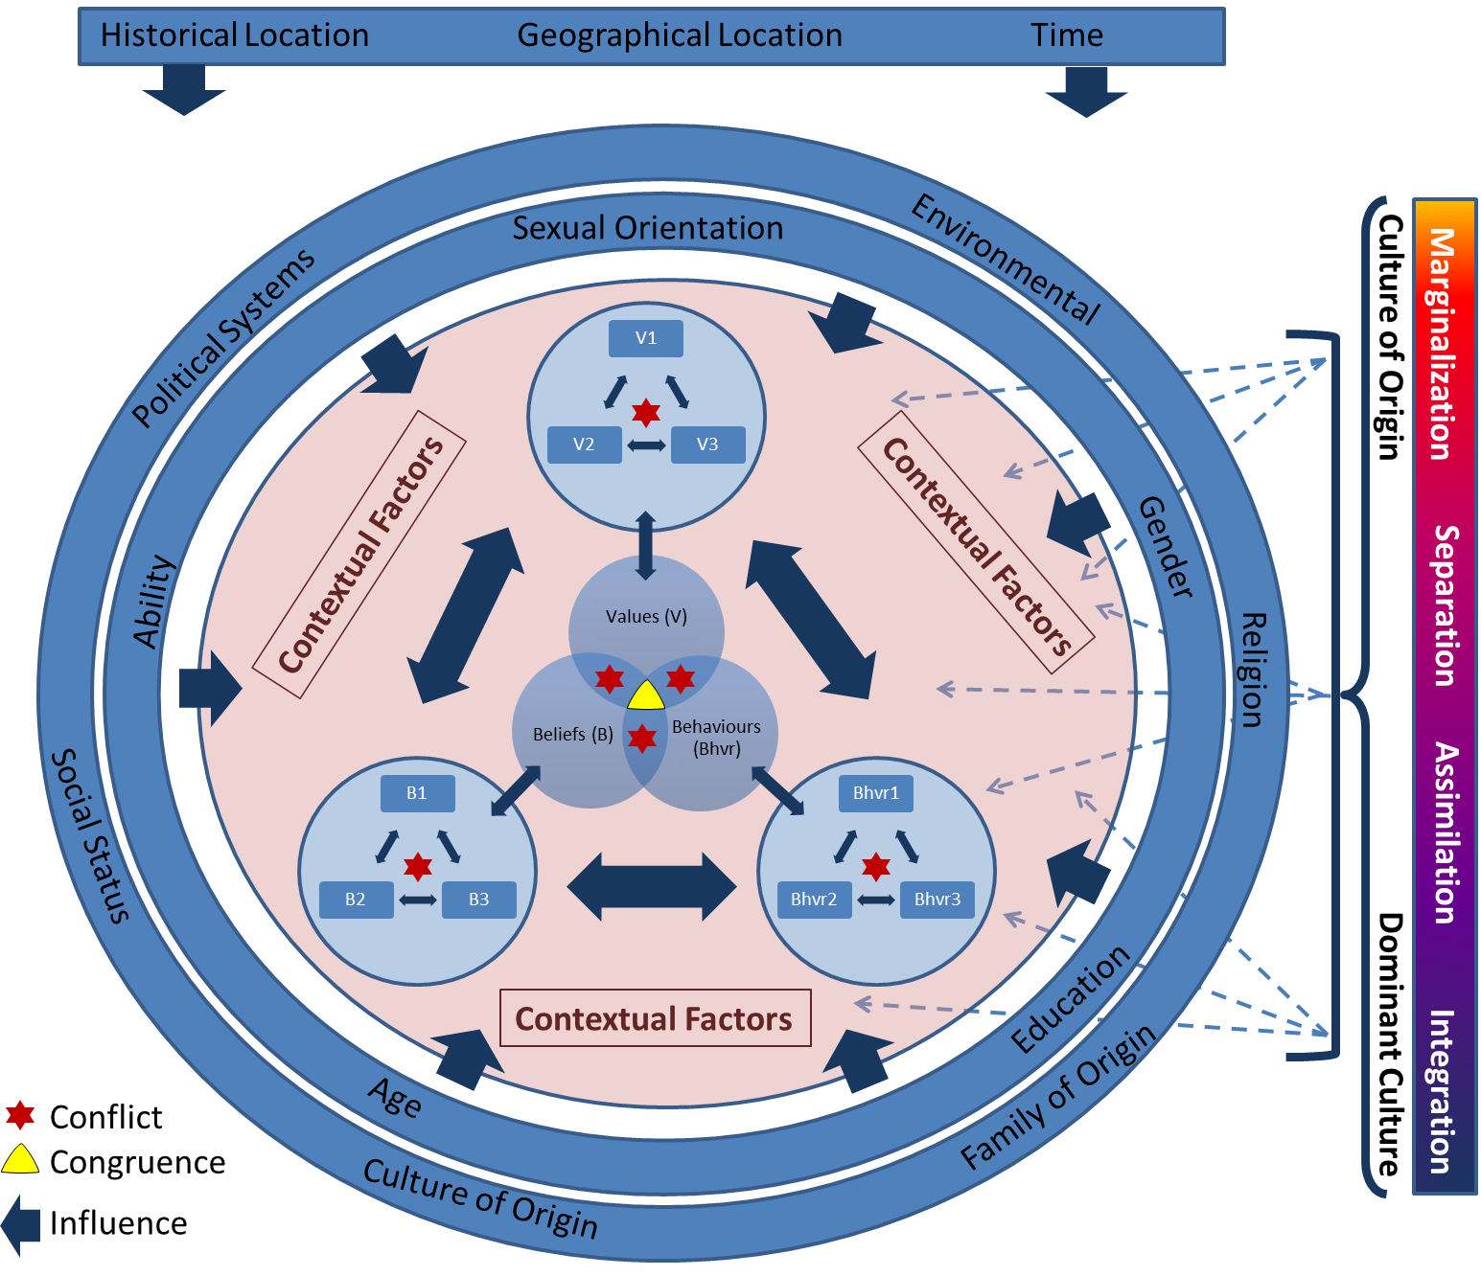

Figure 2. Cultural congruence, represented by the yellow triangle, occurs when values, beliefs, and behaviours are not in conflict. Values, beliefs and behaviours are influenced by several factors such as the ones noted in the outer circles. When values, beliefs and/or behaviour do not line up this creates conflict (i.e., cognitive dissonance). Individuals seek to resolve cognitive dissonance by aligning behaviours, beliefs, and/ or values. The extend to which these line up with the culture of origin and the dominant culture lead to cultural congruency or incongruency depending on the preferred strategy of the individual and the alignment of values, beliefs and behaviours.

