Figure 1. Embodying a Male Identity
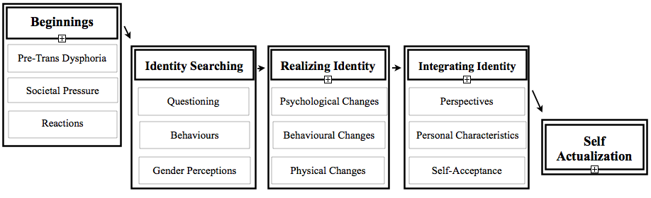
Figure 2. Beginnings

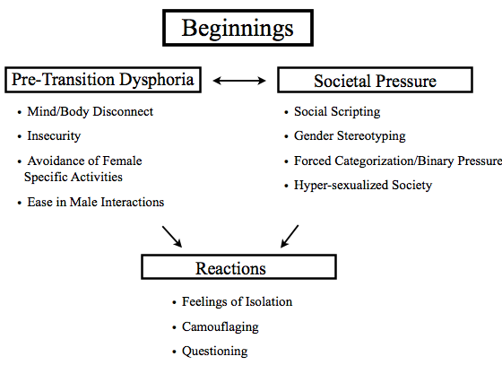
Figure 3. Identity Searching

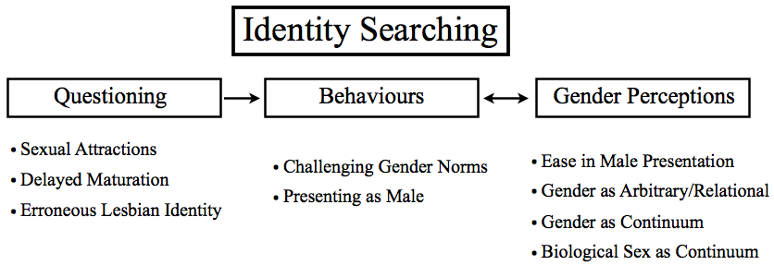
Figure 4. Realizing Identity
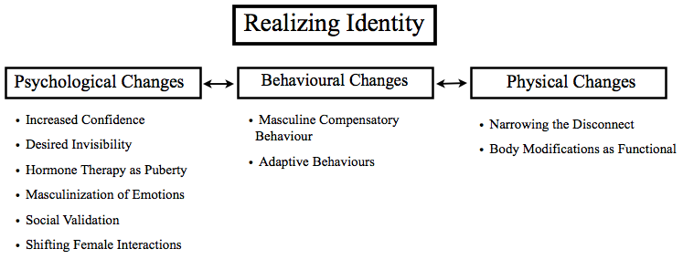

Figure 5. Integrating Identity
