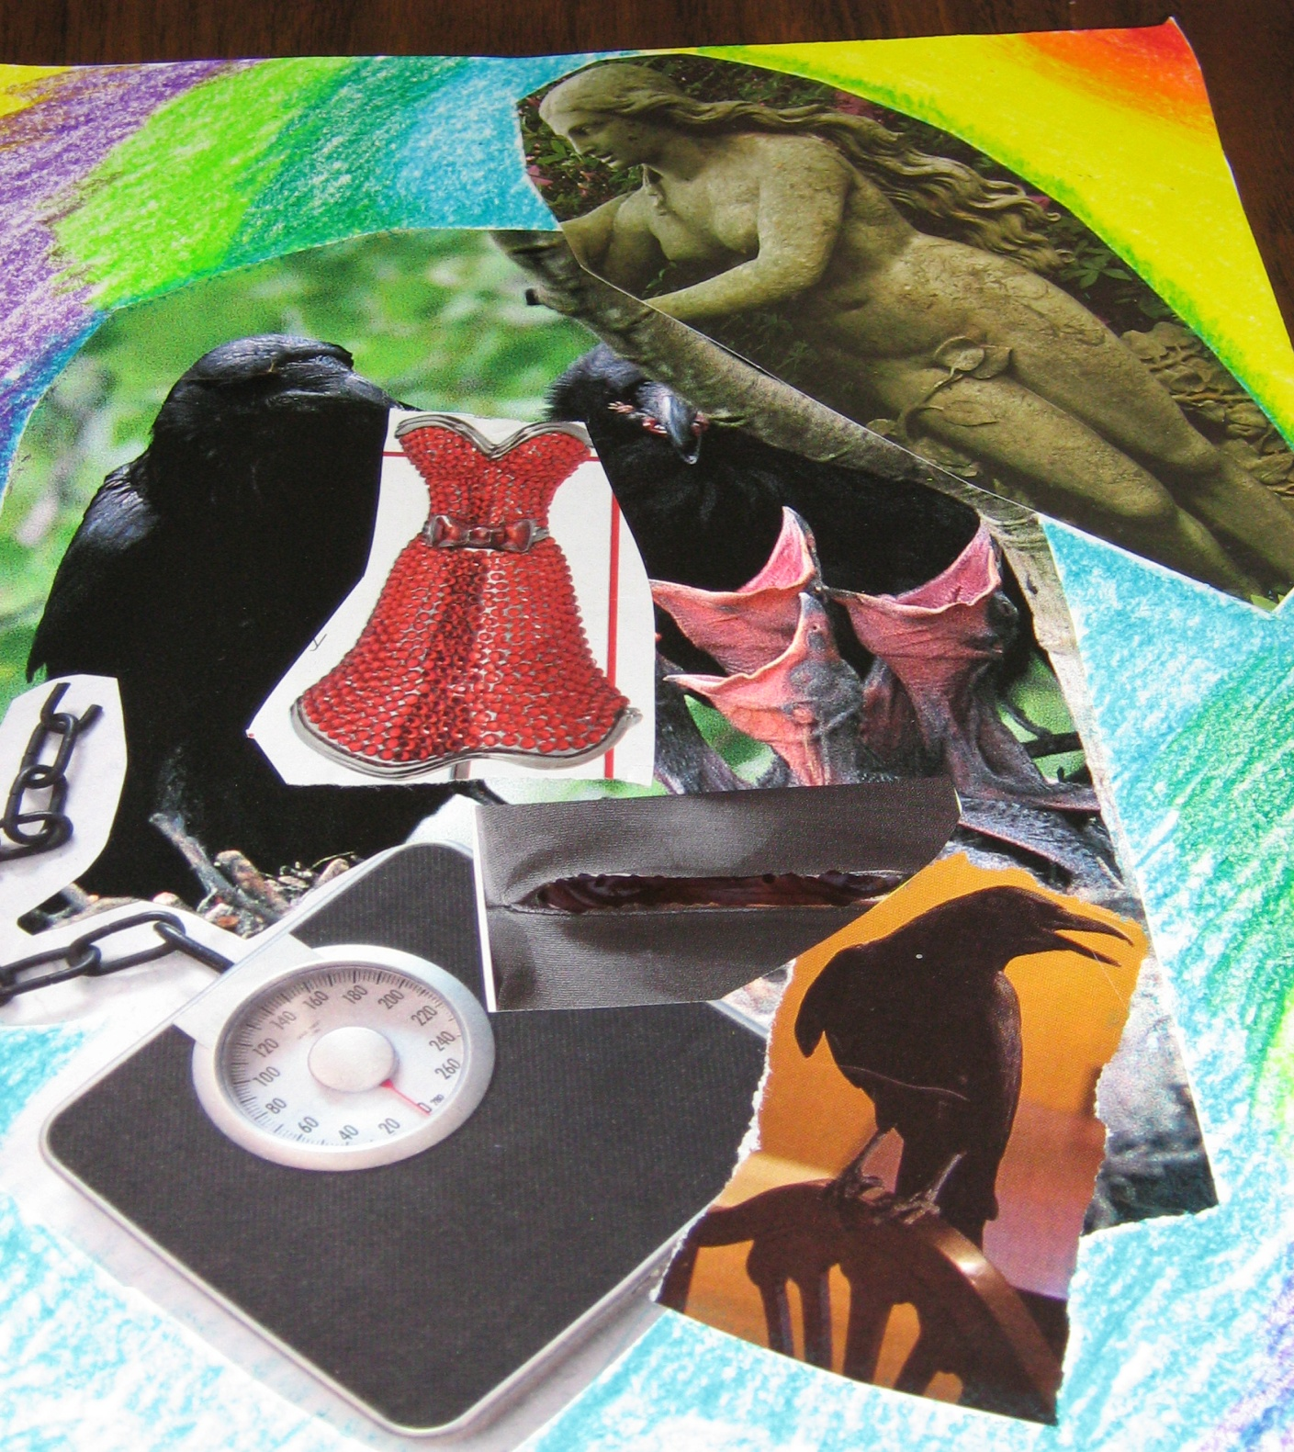

Figure 1. Tina in First Session: The Fear of Needing So Much

